**Night Light Owl**

The name is Night Light Owl and the owl is supposed to turn its head and emit a light when the room is dark, and stop movent and go dark when the light was on. My original fan motor’s wire broke and I had to substitute for a step motor at the last second. The Processing sketch is supposed to act as a controller. If the left arrow is pressed, the head will turn left and as well as the right arrow making the owl turn right. The eyes in the sketch are to help indicate that the lights in the owl are also on.

In this project I used a stepper motor, two LEDs, some cardboard, and a photosensor.

**Here is how I made the owl**

I tried to create an owl out of cardboard, the head and body would be separate parts that would join together at the step motor. The wings were now stationary, as the cardboard could not support that much movement. The bird would fall over a lot, due to the material and the wires kept having to be pushed into place, as the cardboard kept uprooting the wires.

First, this is how I created the owl.

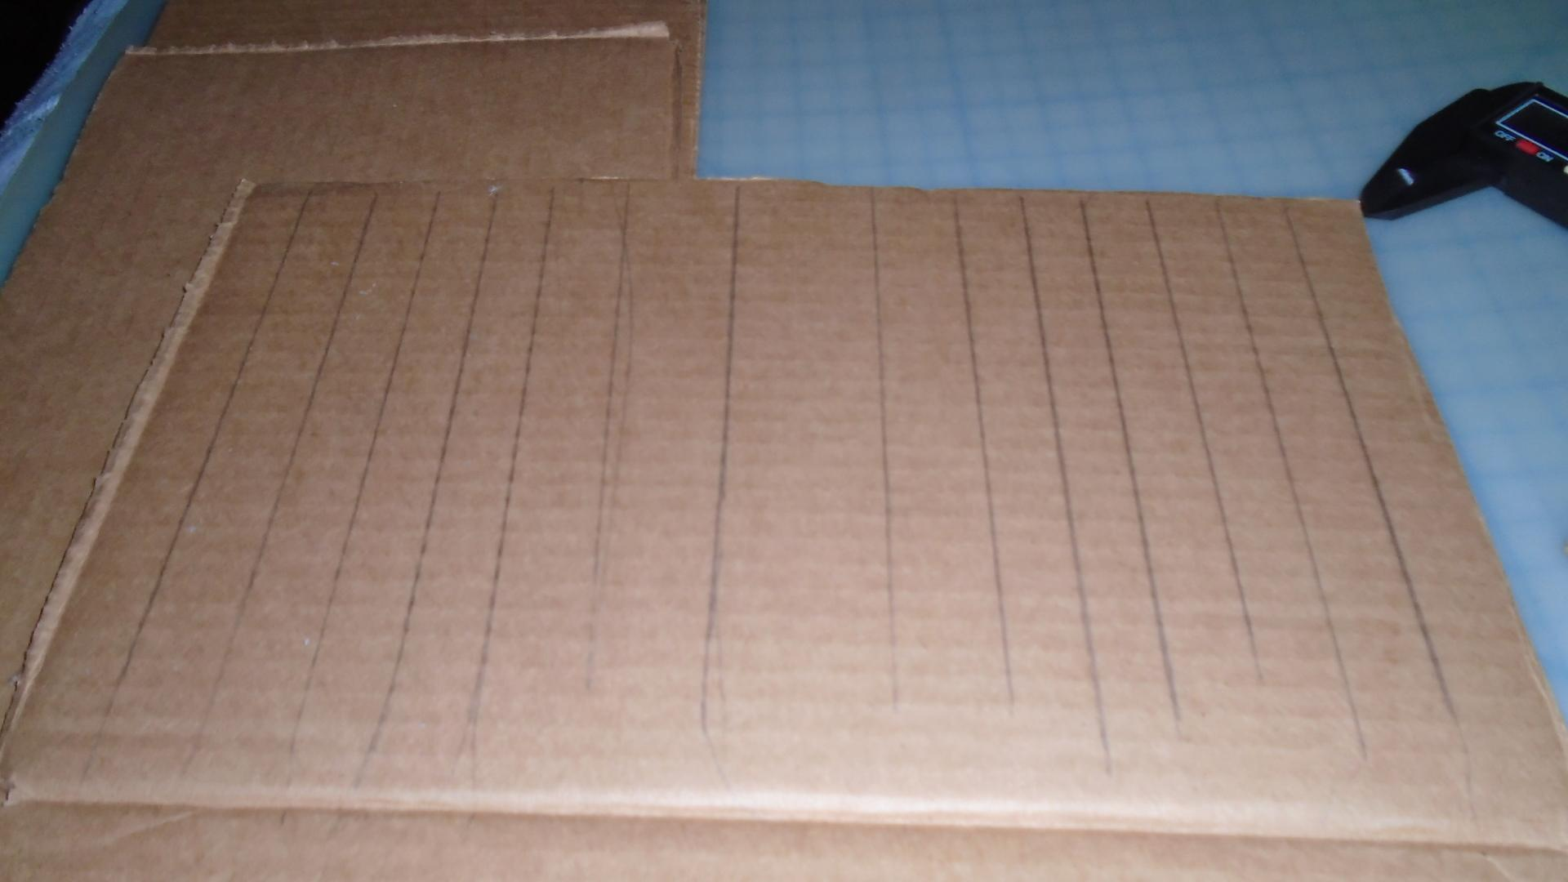

I had to cut fold lines into a piece of cardboard, in order to fold it into a round shape. Then I cut the pieces in two, with one smaller than the other; one half for the body and the other for the head.

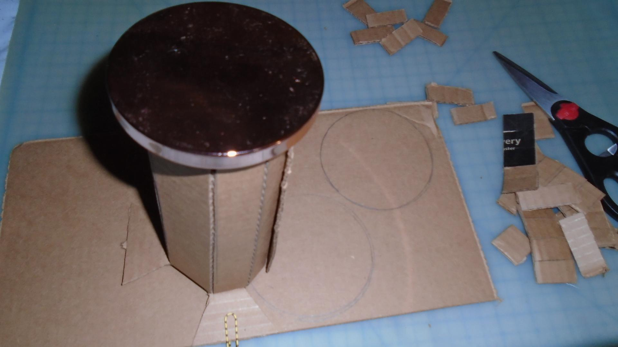

Next, I cut out circles that would be capped for the head and body, I also gave it feet for aesthetic purposes.

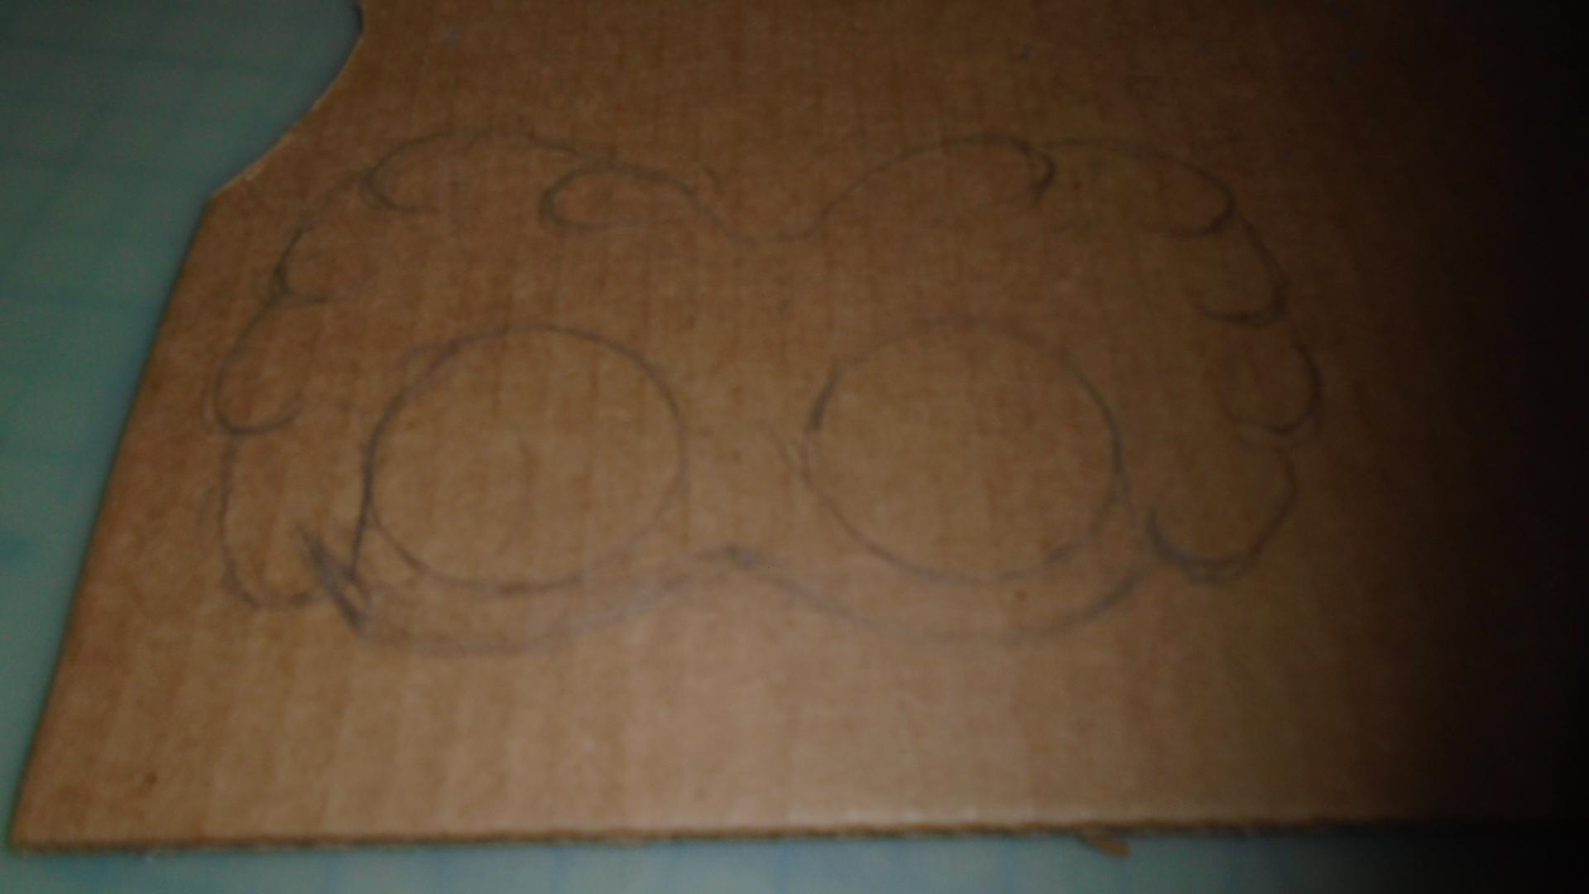

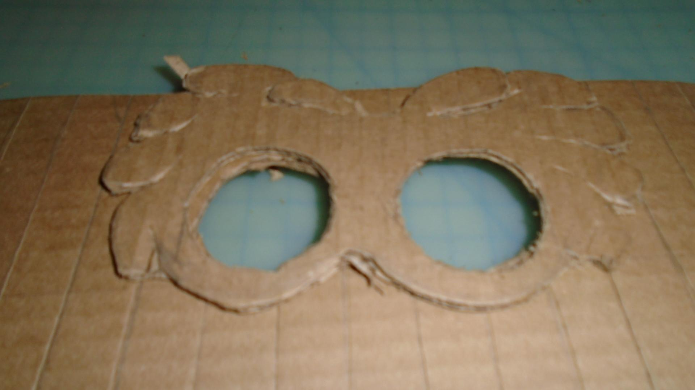

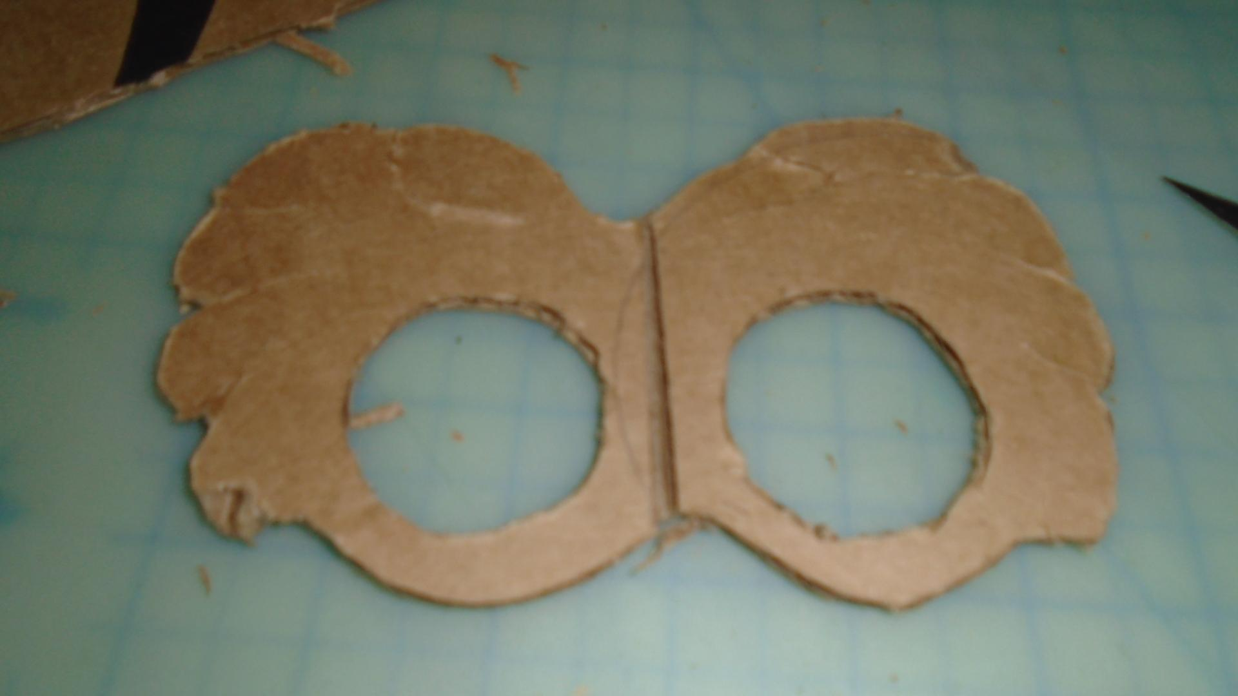

Next, I cut out a mask for the ace to make the eyes have more of a ruffled feather-like look, then I cut a line in the middle to make it bend against the cylinder face more easily.

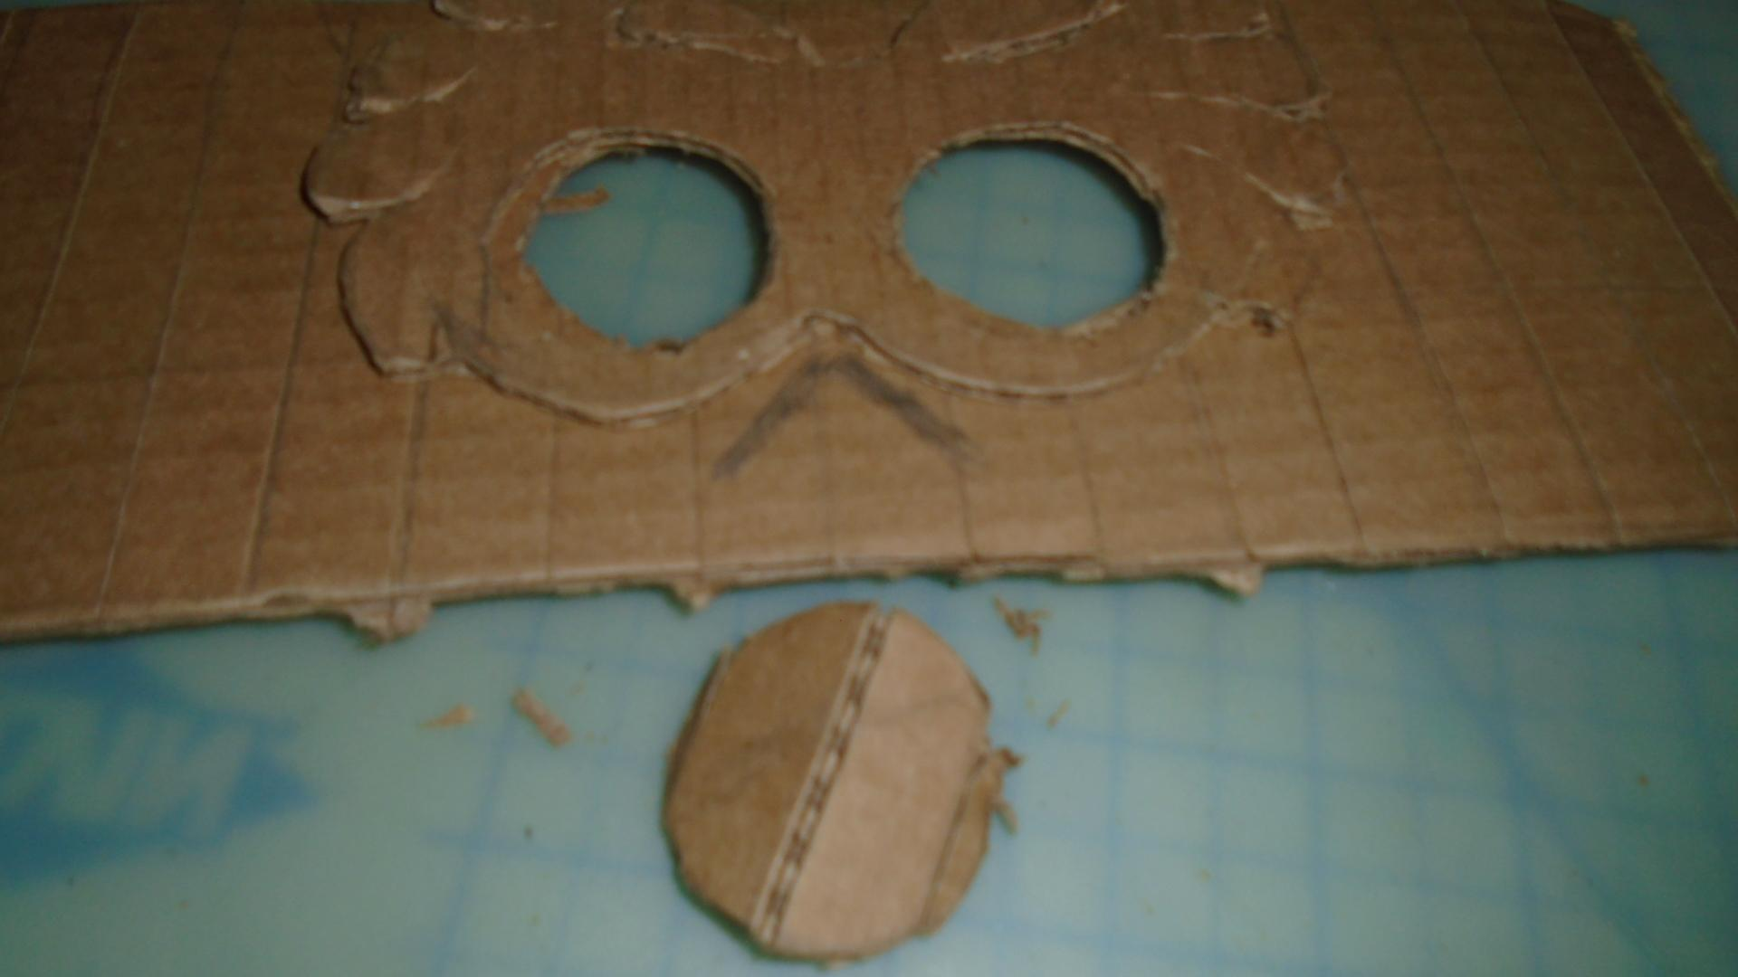

After cutting holes into the face and made an incision for the beak, this was when my Exacto knife began to get duller, the cuts began to tear the cardboard as it cut (as seen at the bottom.)

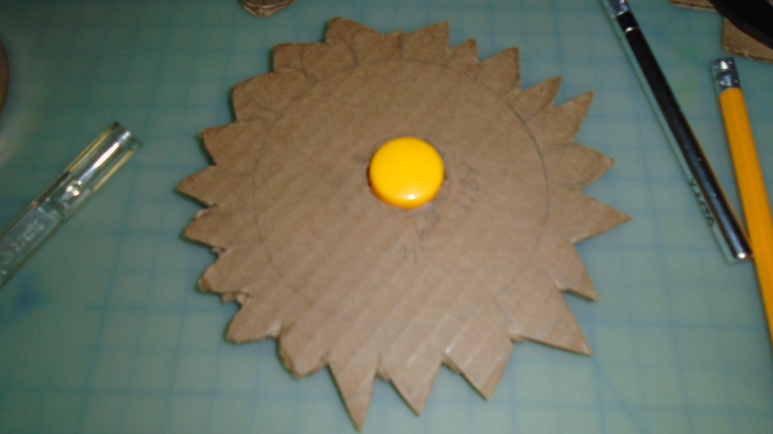

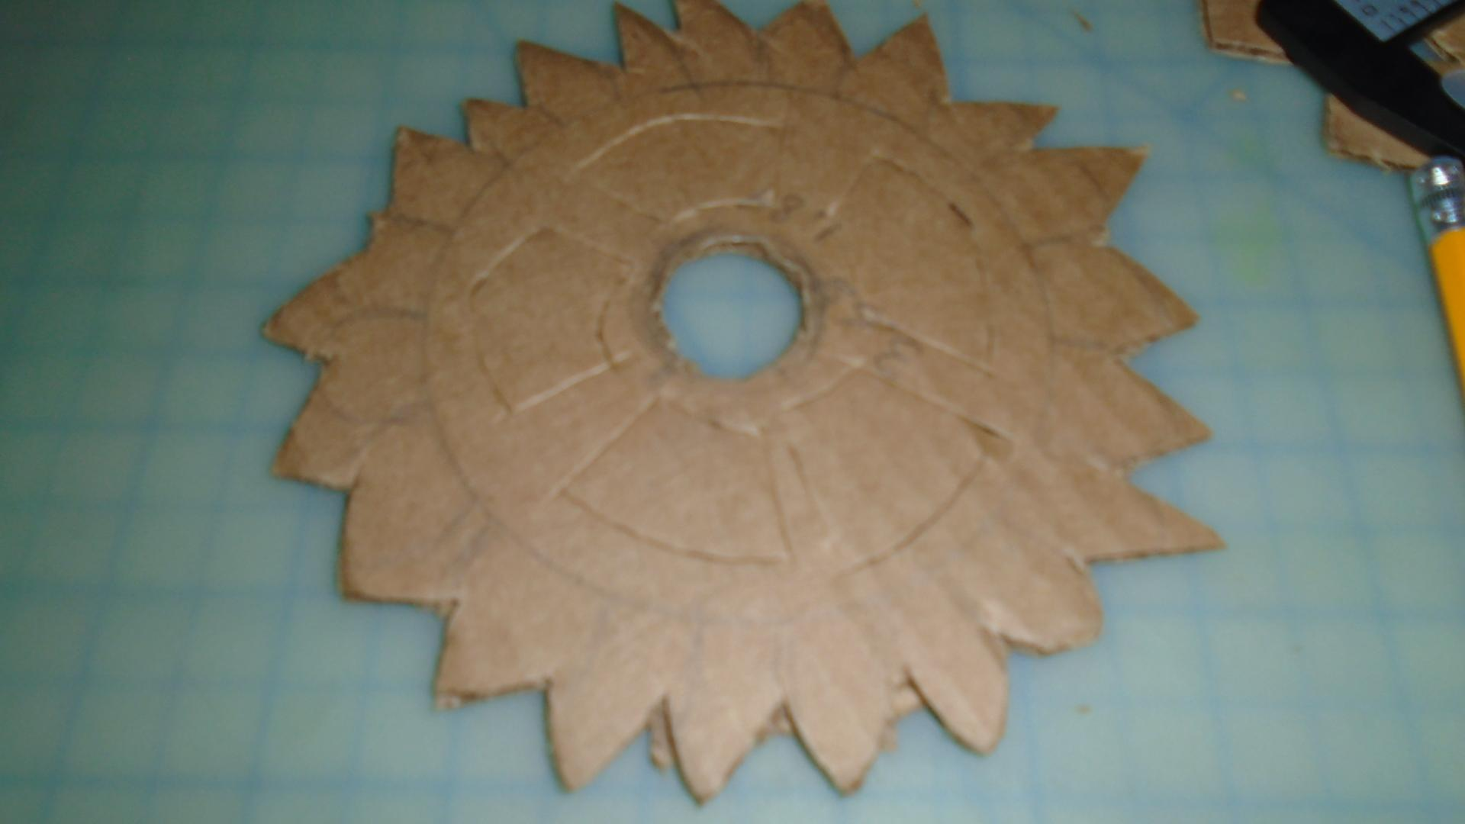

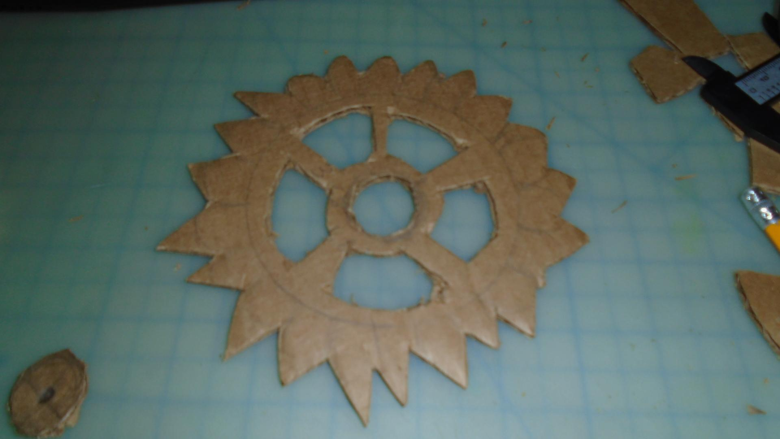

My plan at first was to make a gear that would support the head and allow it to spin on the fan motor, the circle in the middle was for the yellow part and the holes around it were to let the light from the LED’s at the bottom shine through.

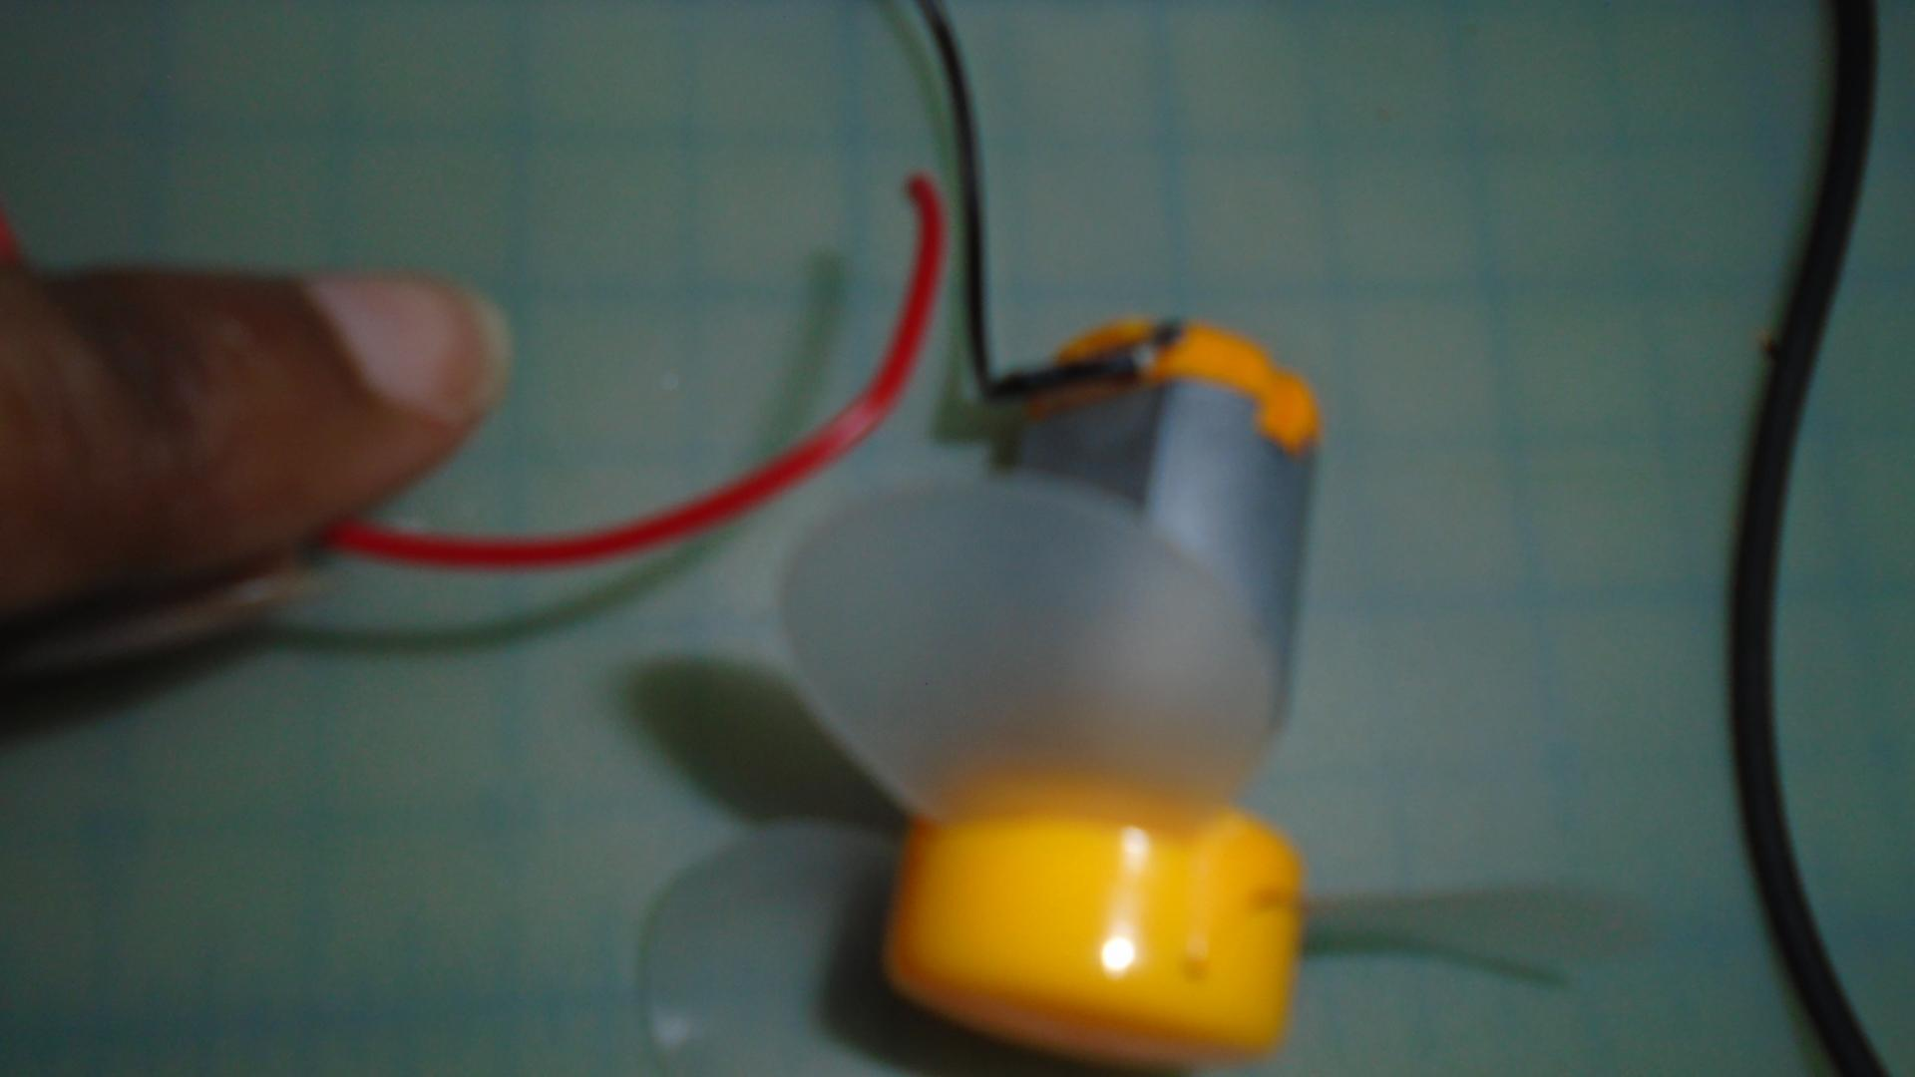

However, as I was working with the motor, I noticed that the fan no longer turns and checked my wires to see that the motor’s red wire broke. I panicked before realizing that I could try to use a new motor and did a lot of research into how a step motor worked.

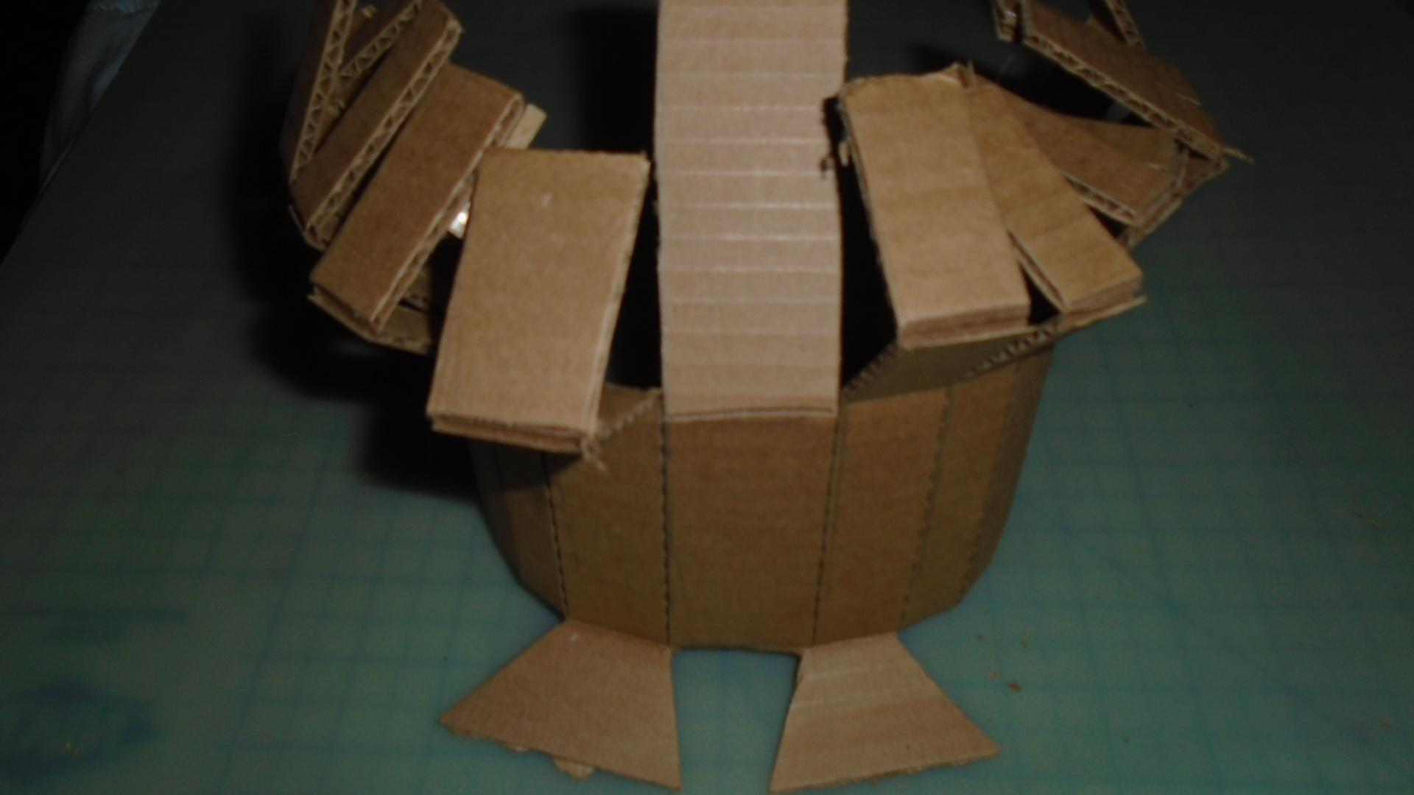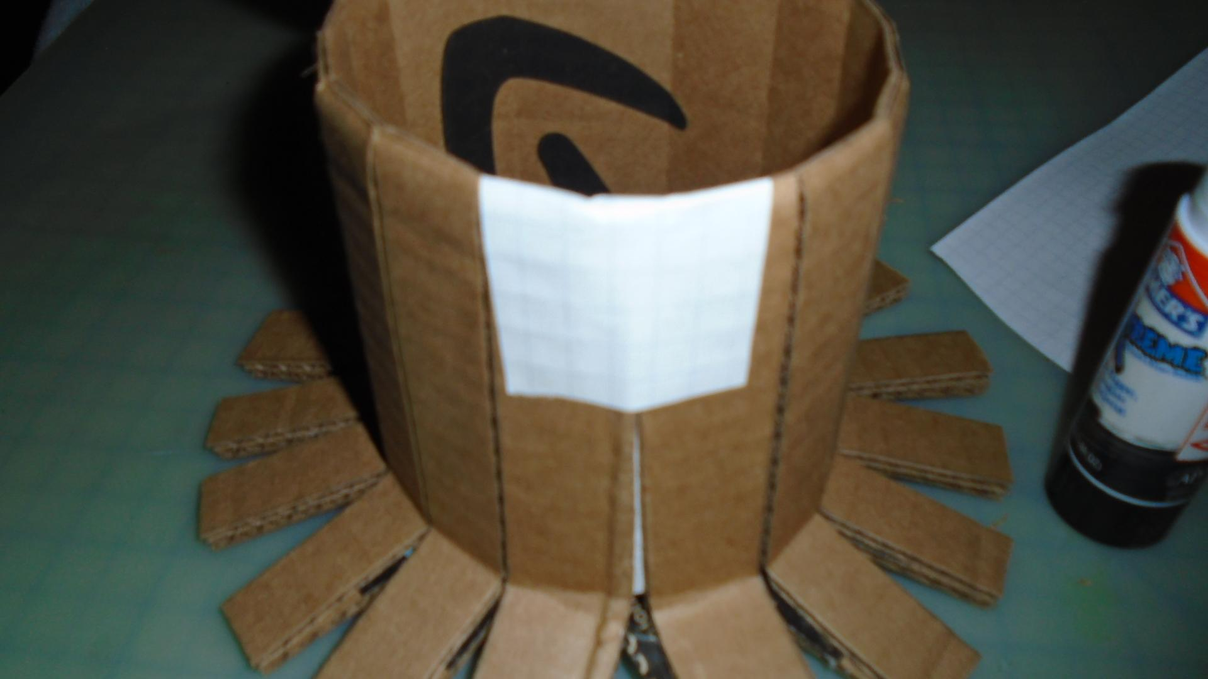

This is the body and I was planning on cutting away at the strips at the top to make them look like ruffled feathers, but the knife made it too difficult so I just cut them off and made it simple. Then I glued a paper to the bottom back to make way for the servo motor.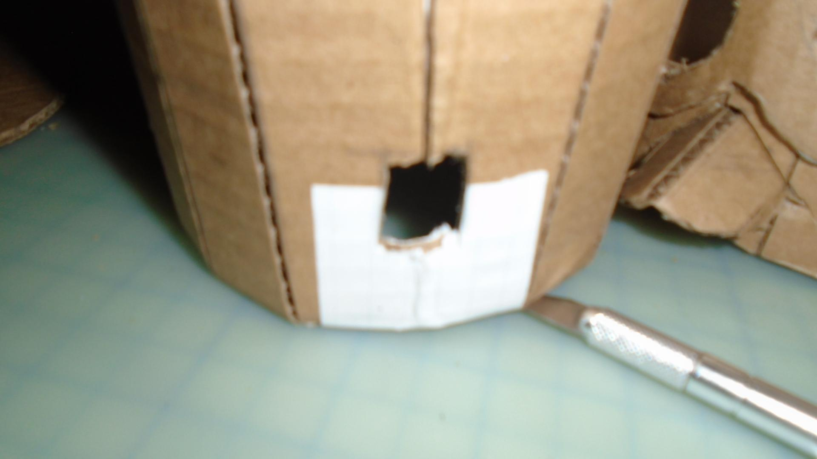

However, the wings could not flap and the motor was not operating well, there was also the problem of trying to attach the wings to strings that went through the bird. I decided to just attach the wings to the side and forget about making them move.

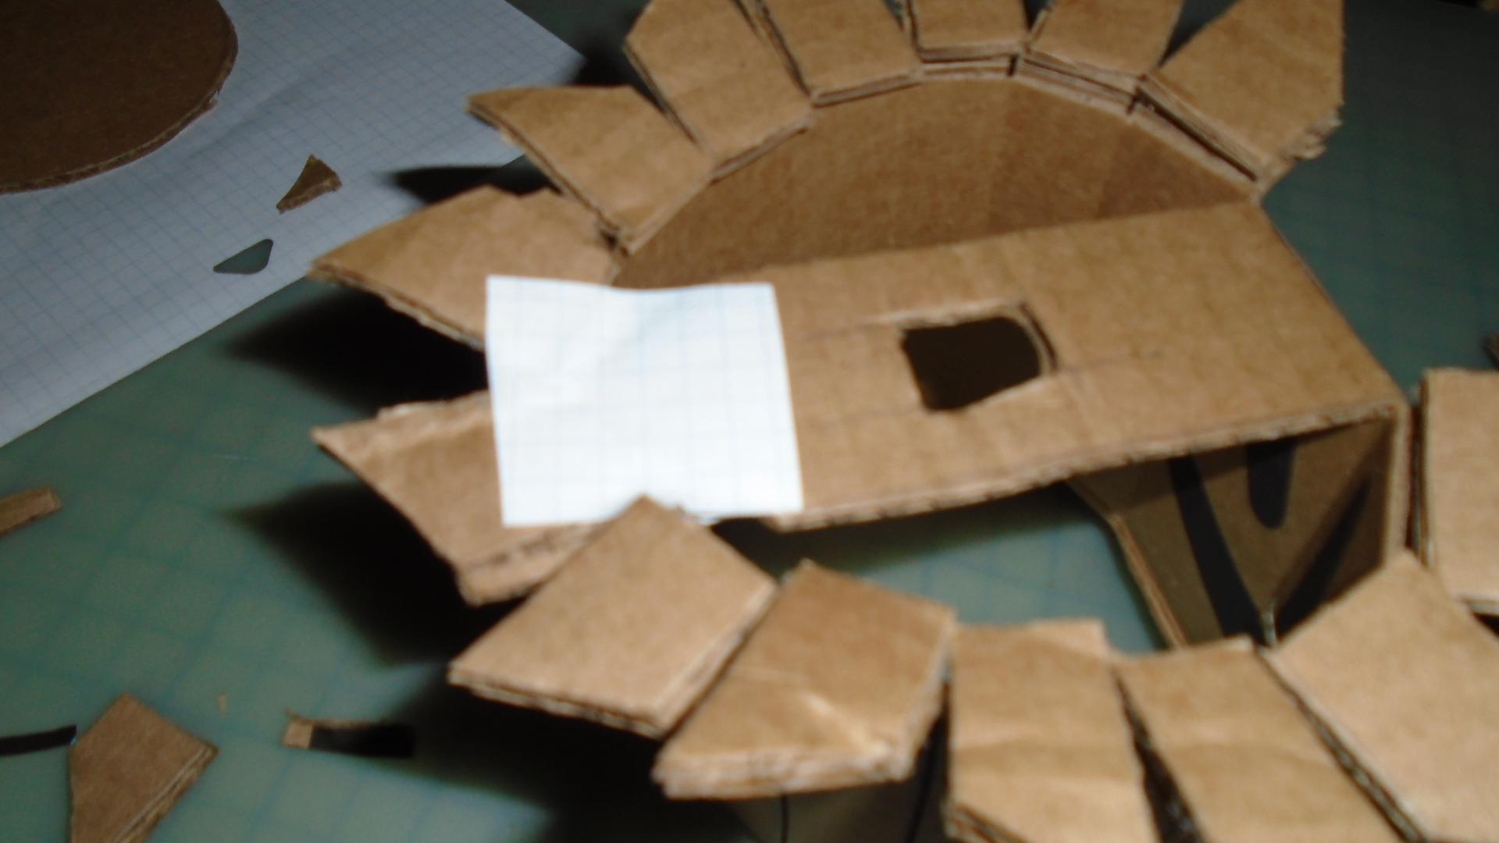

This incision would have been where the motor fan motor would have gone, but I had to tear that part off and make a new piece to hold the step motor.

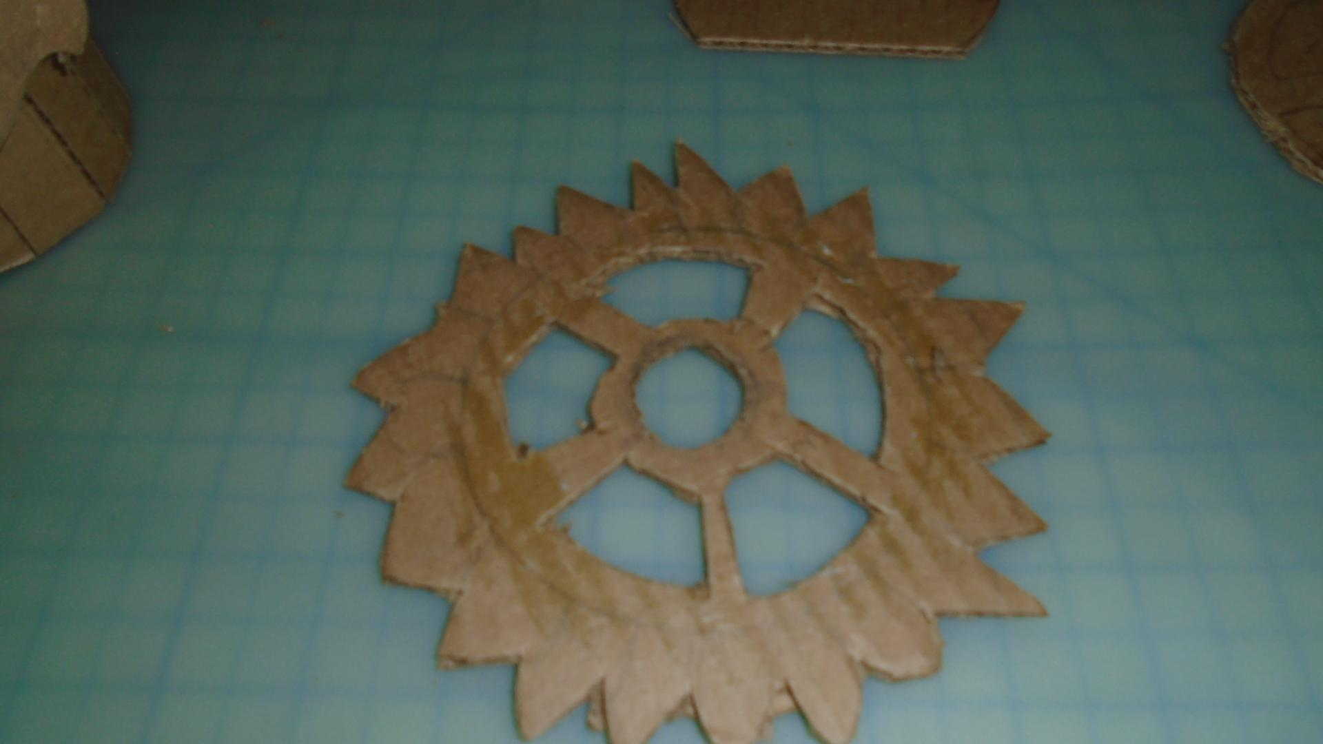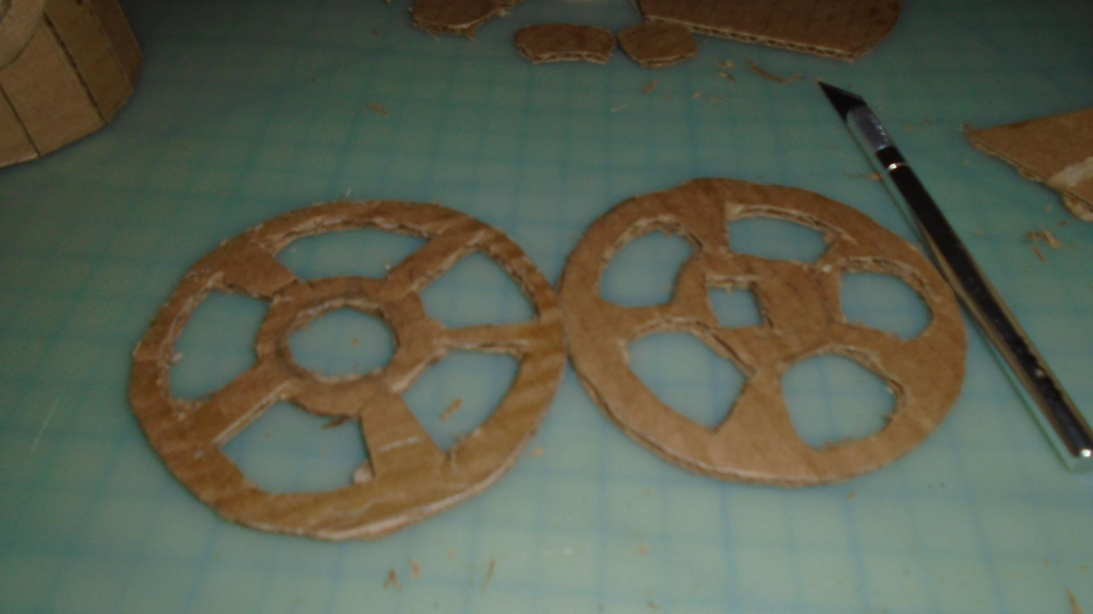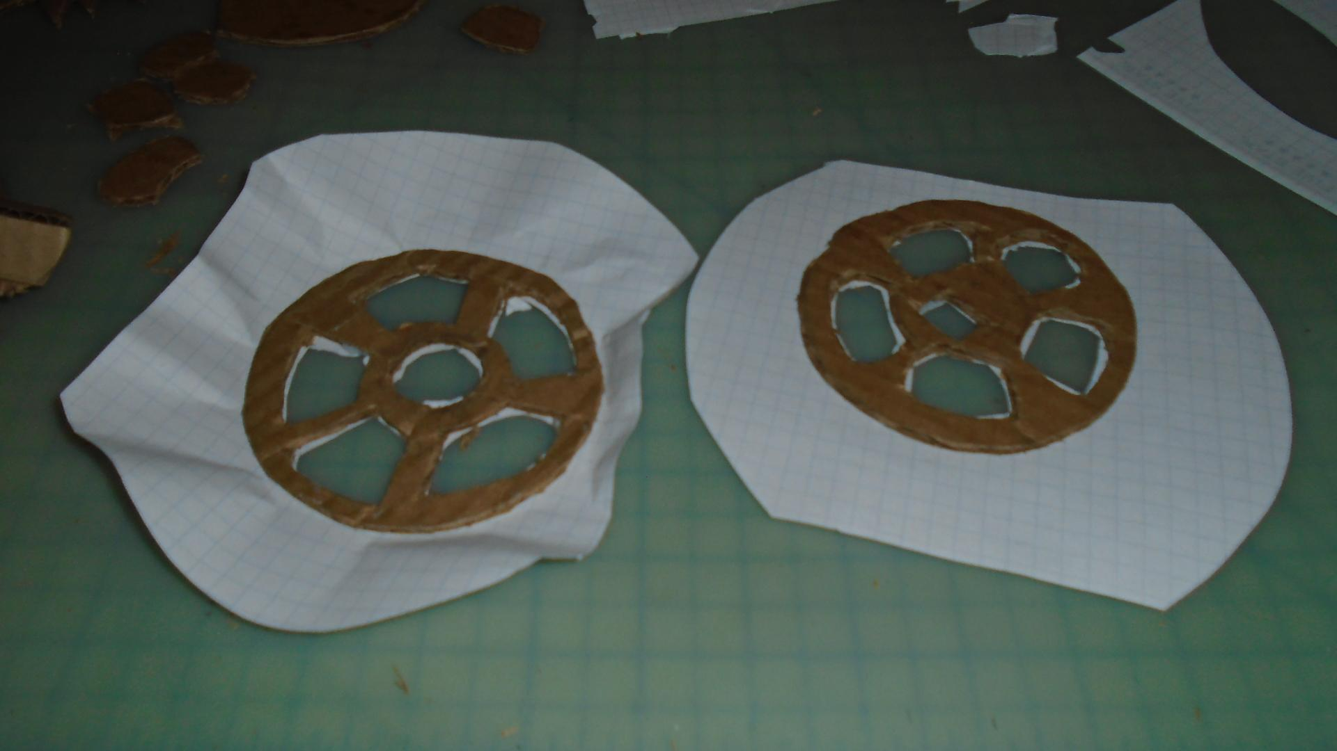

I decided to cut off the spikes from the first wheel and use it as a base to hold the head and the other one to be a base for the step motor. In order to make the wheels stay in place, I glued them to appear that I would glue to the inside of the owl, to make a floor.

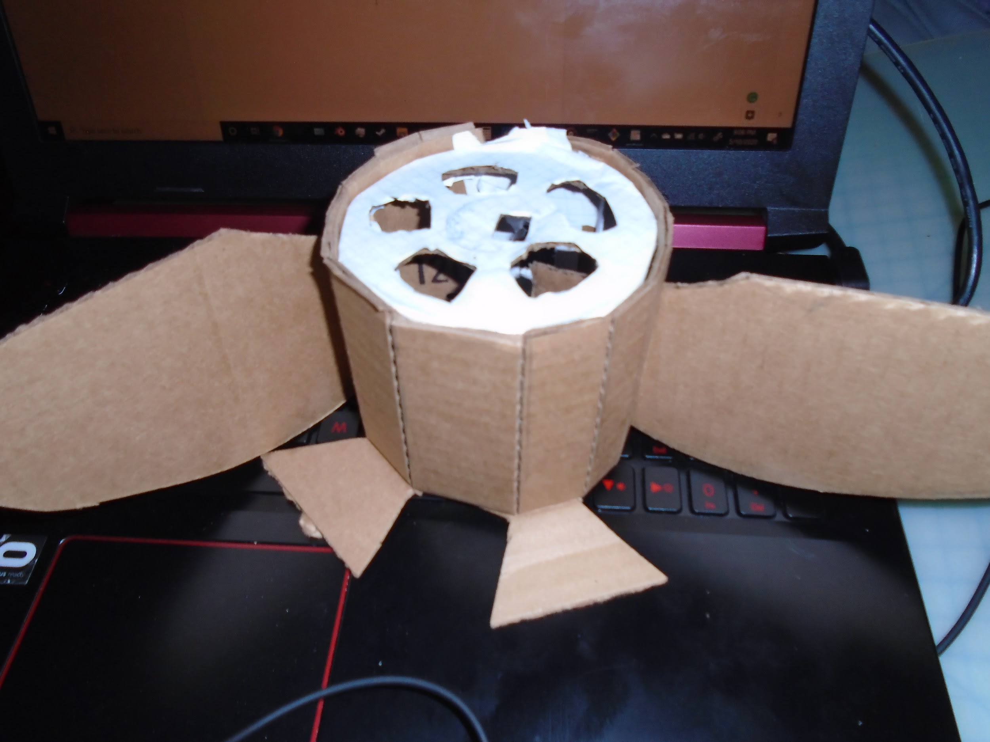

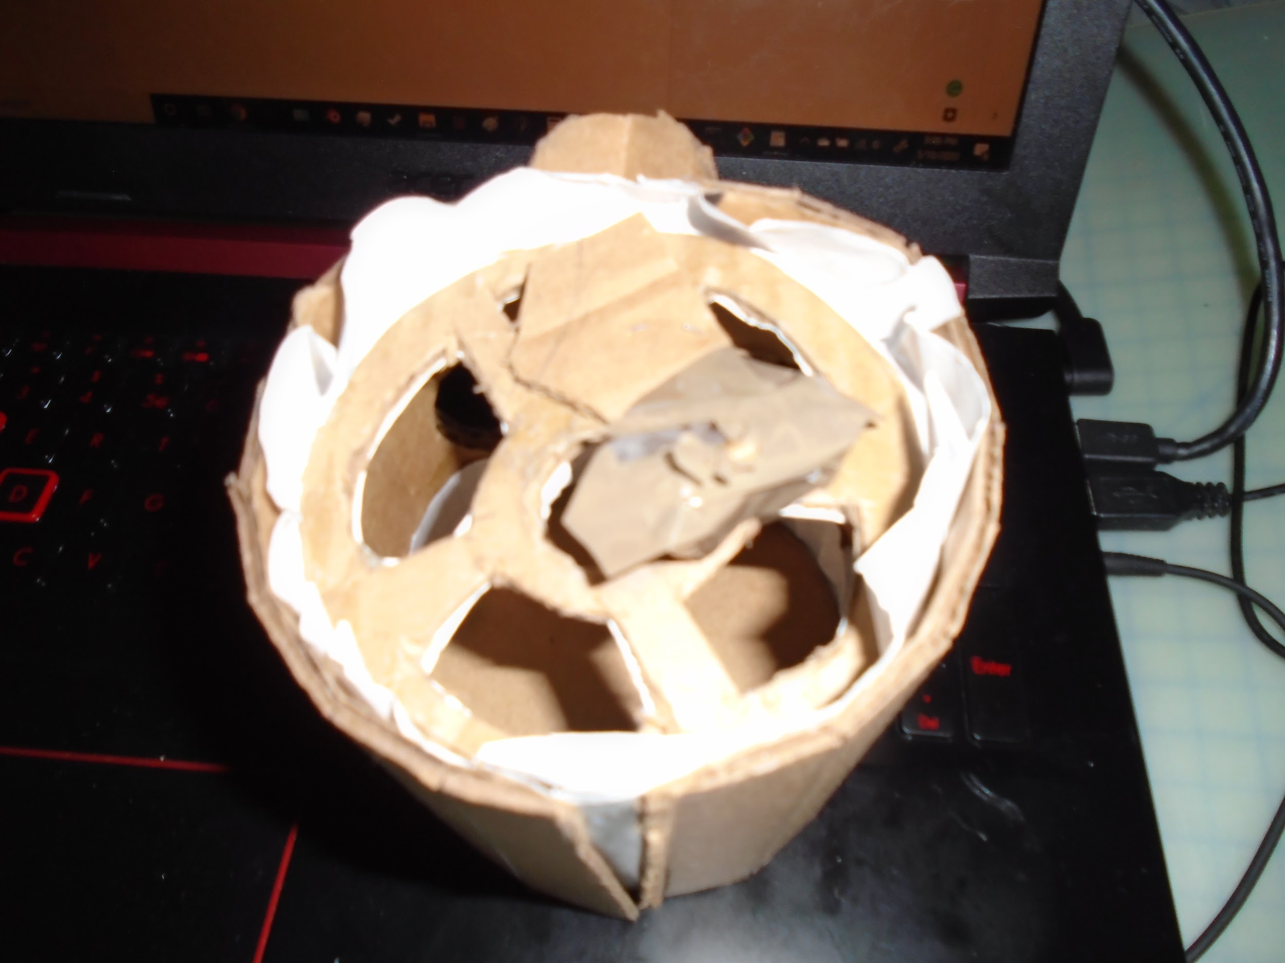

The top is the body with the ‘floor’ and the bottom it the head with the ‘floor’. The most difficult thing about this whole setup was the step motor not having a good part to place on the tip, it didn’t come with a ‘fan’ part and I spent hours trying to get the head to attach to it. I used glue, tape, staples, nails, paper before finally dicing to staple a lot of cardboard together, wrap a metal could around the step motor’s tip, and attach the head to the boy that way. The bottom shows the cardboard and tape that I tried to use.

Wires and code:

Next, I did the wiring and the coding and found it difficult to code for the step motor and make it move. It was an issue with the wires and knowing which wire went where. 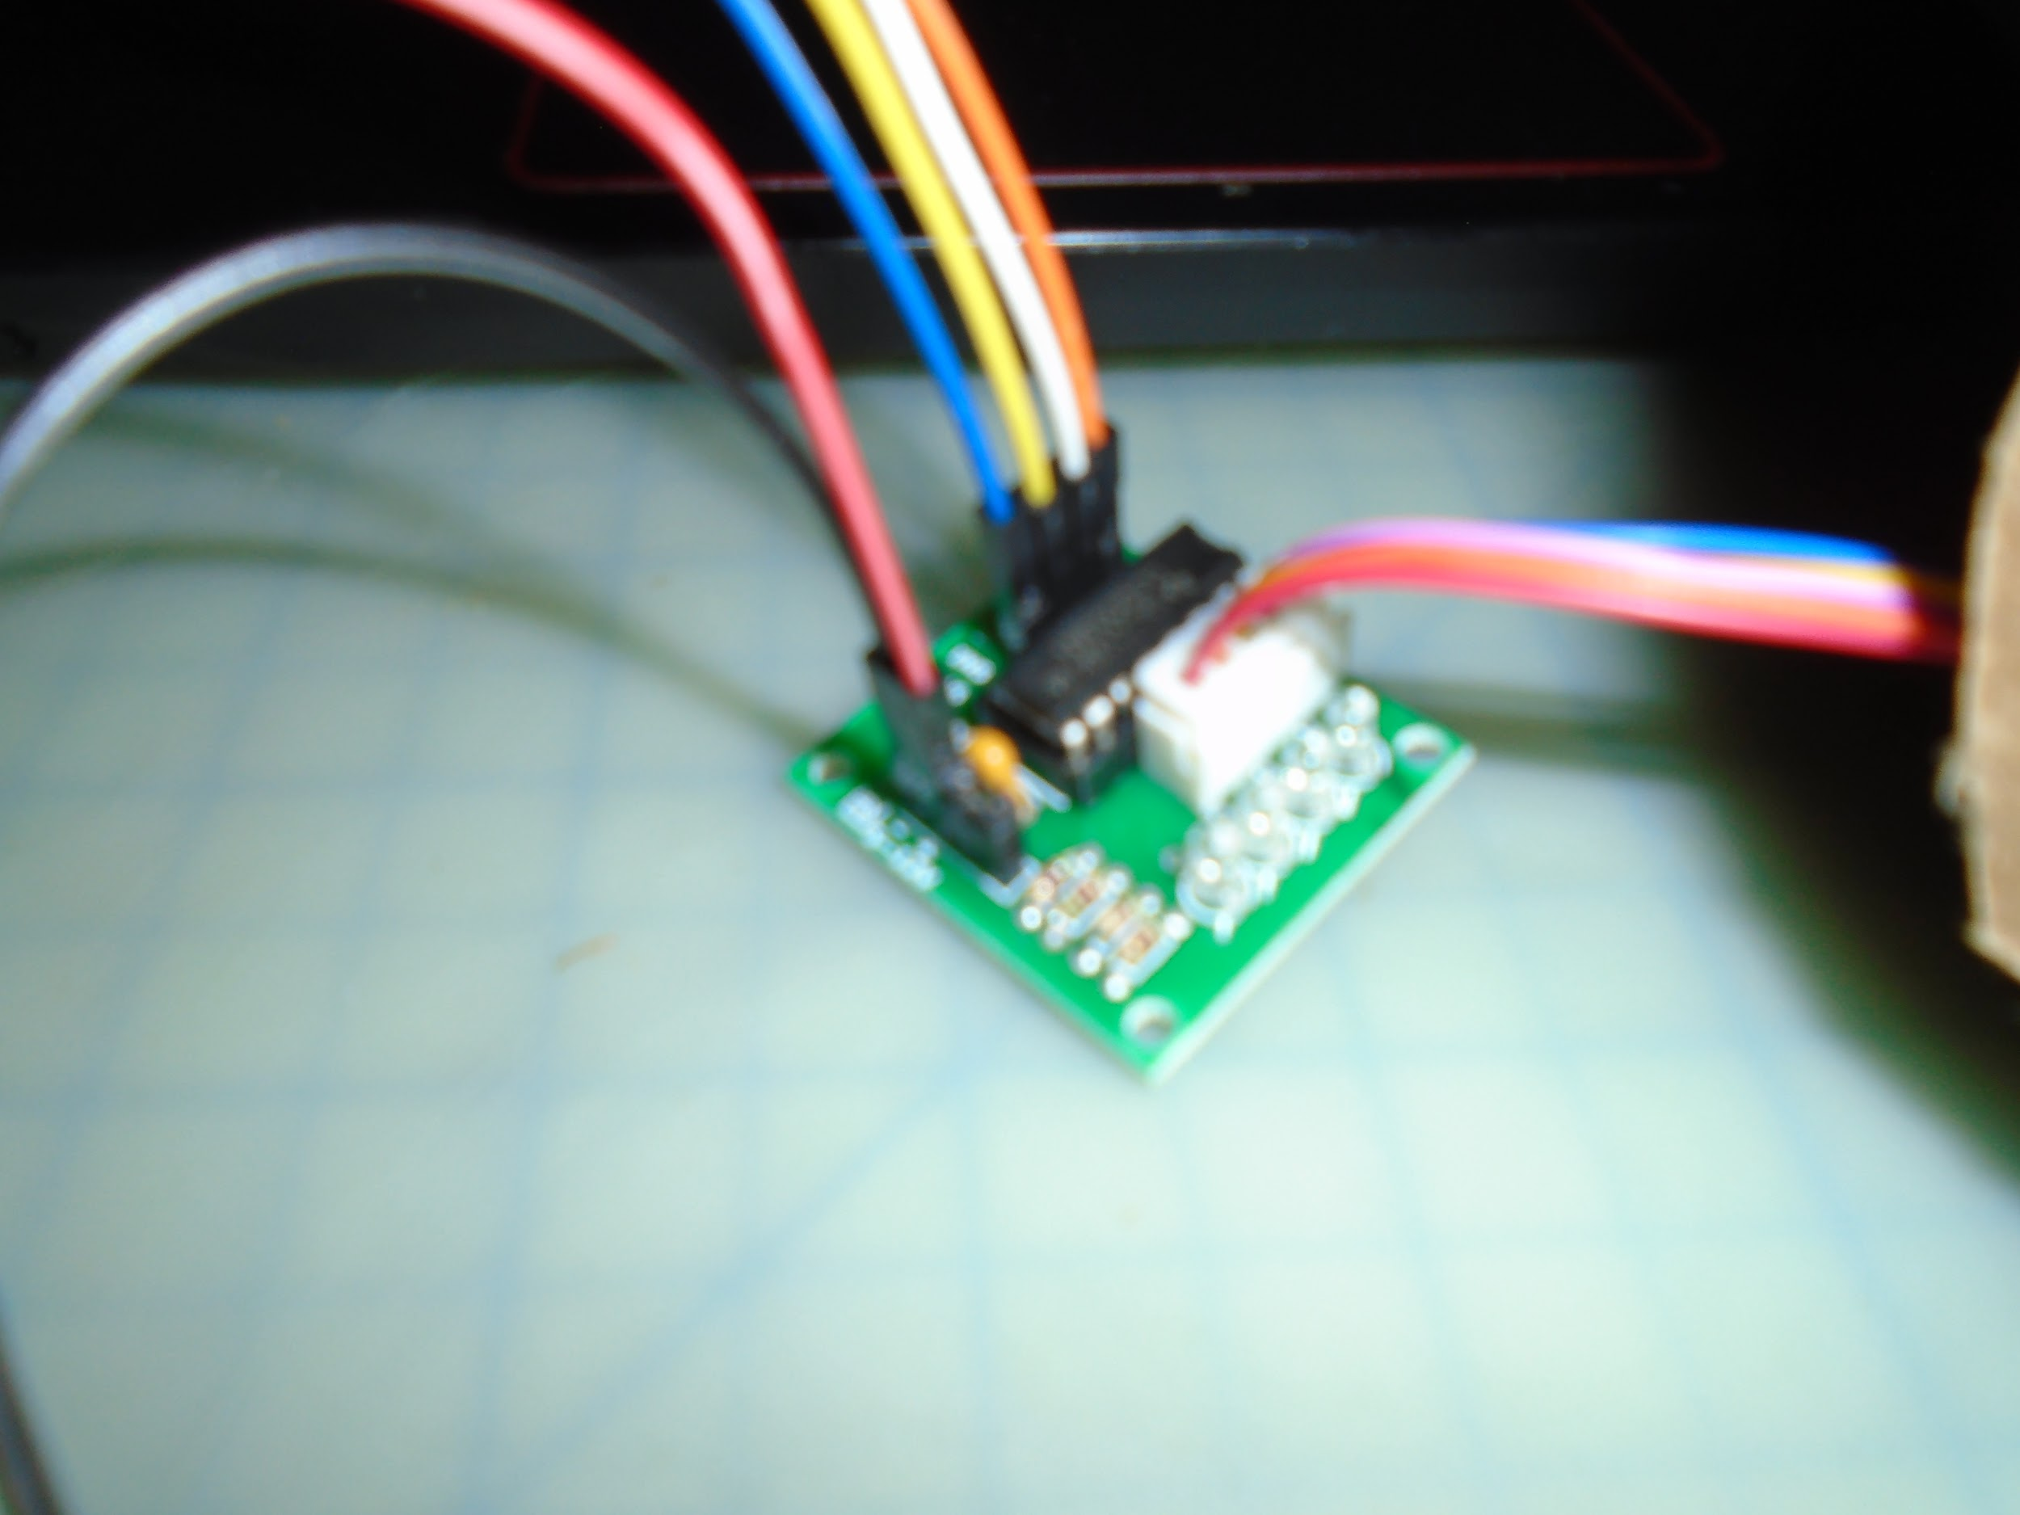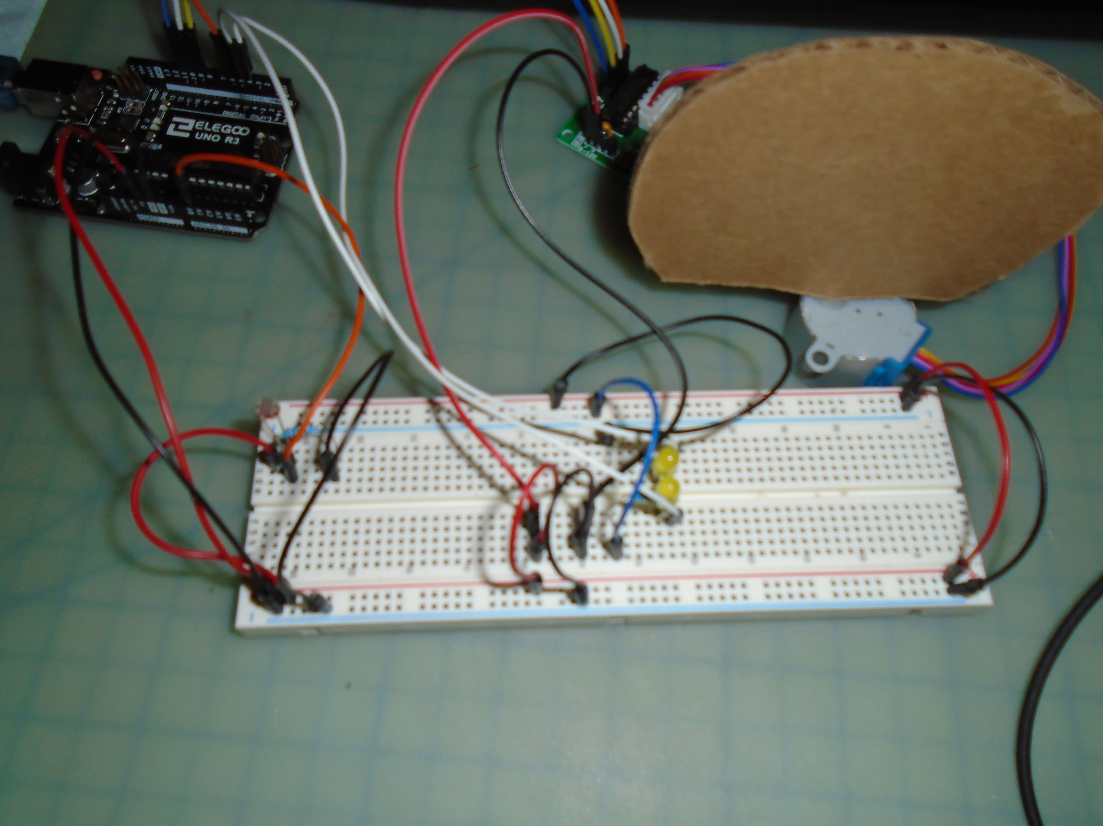

Finally, this is what I created, the head moves and it lights up, but it is very janky and falls apart easily.

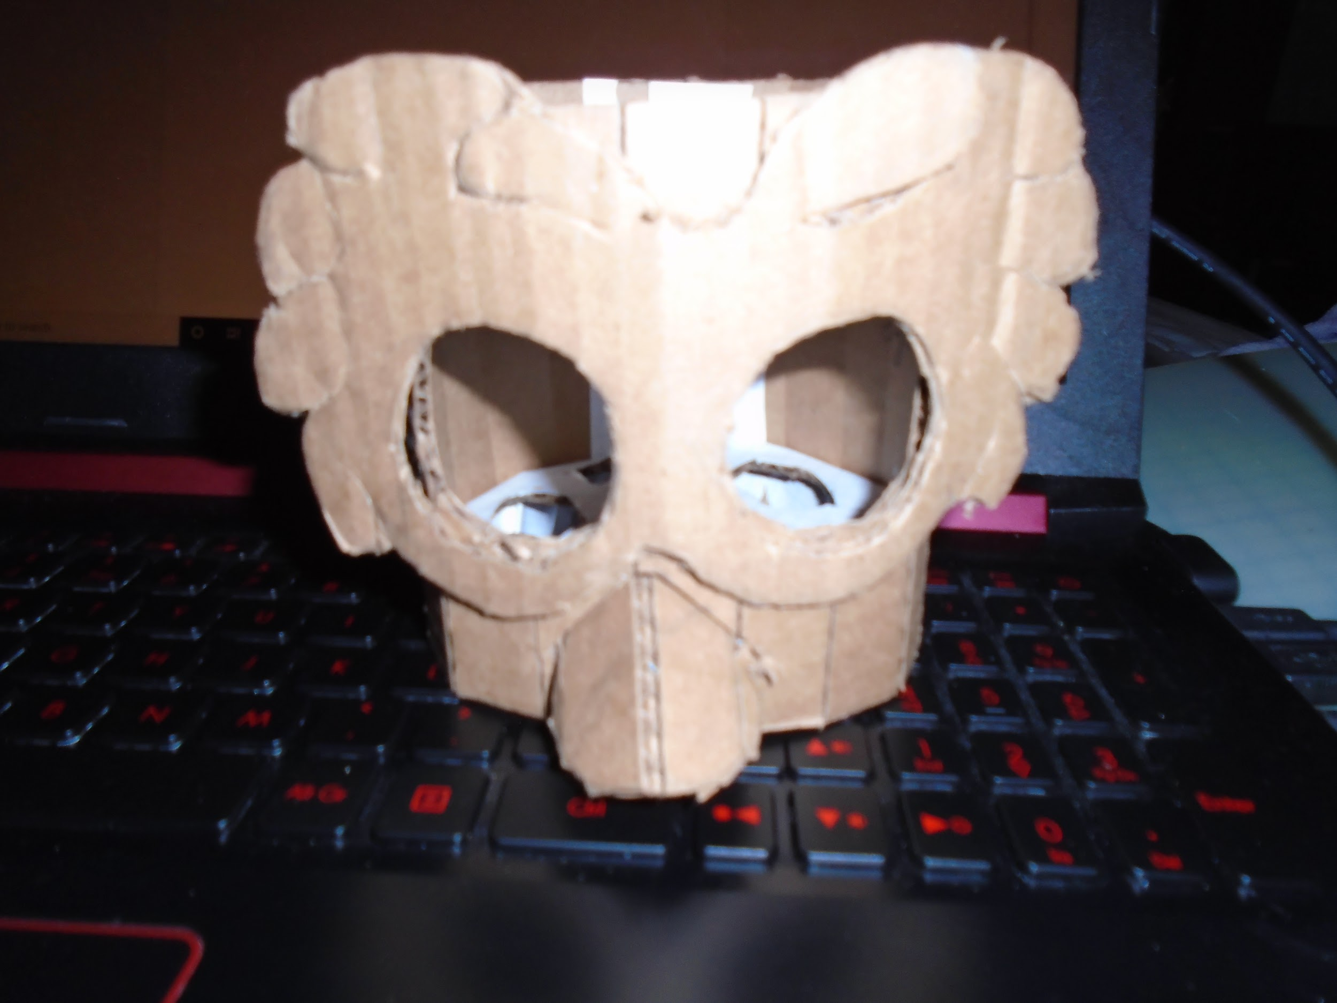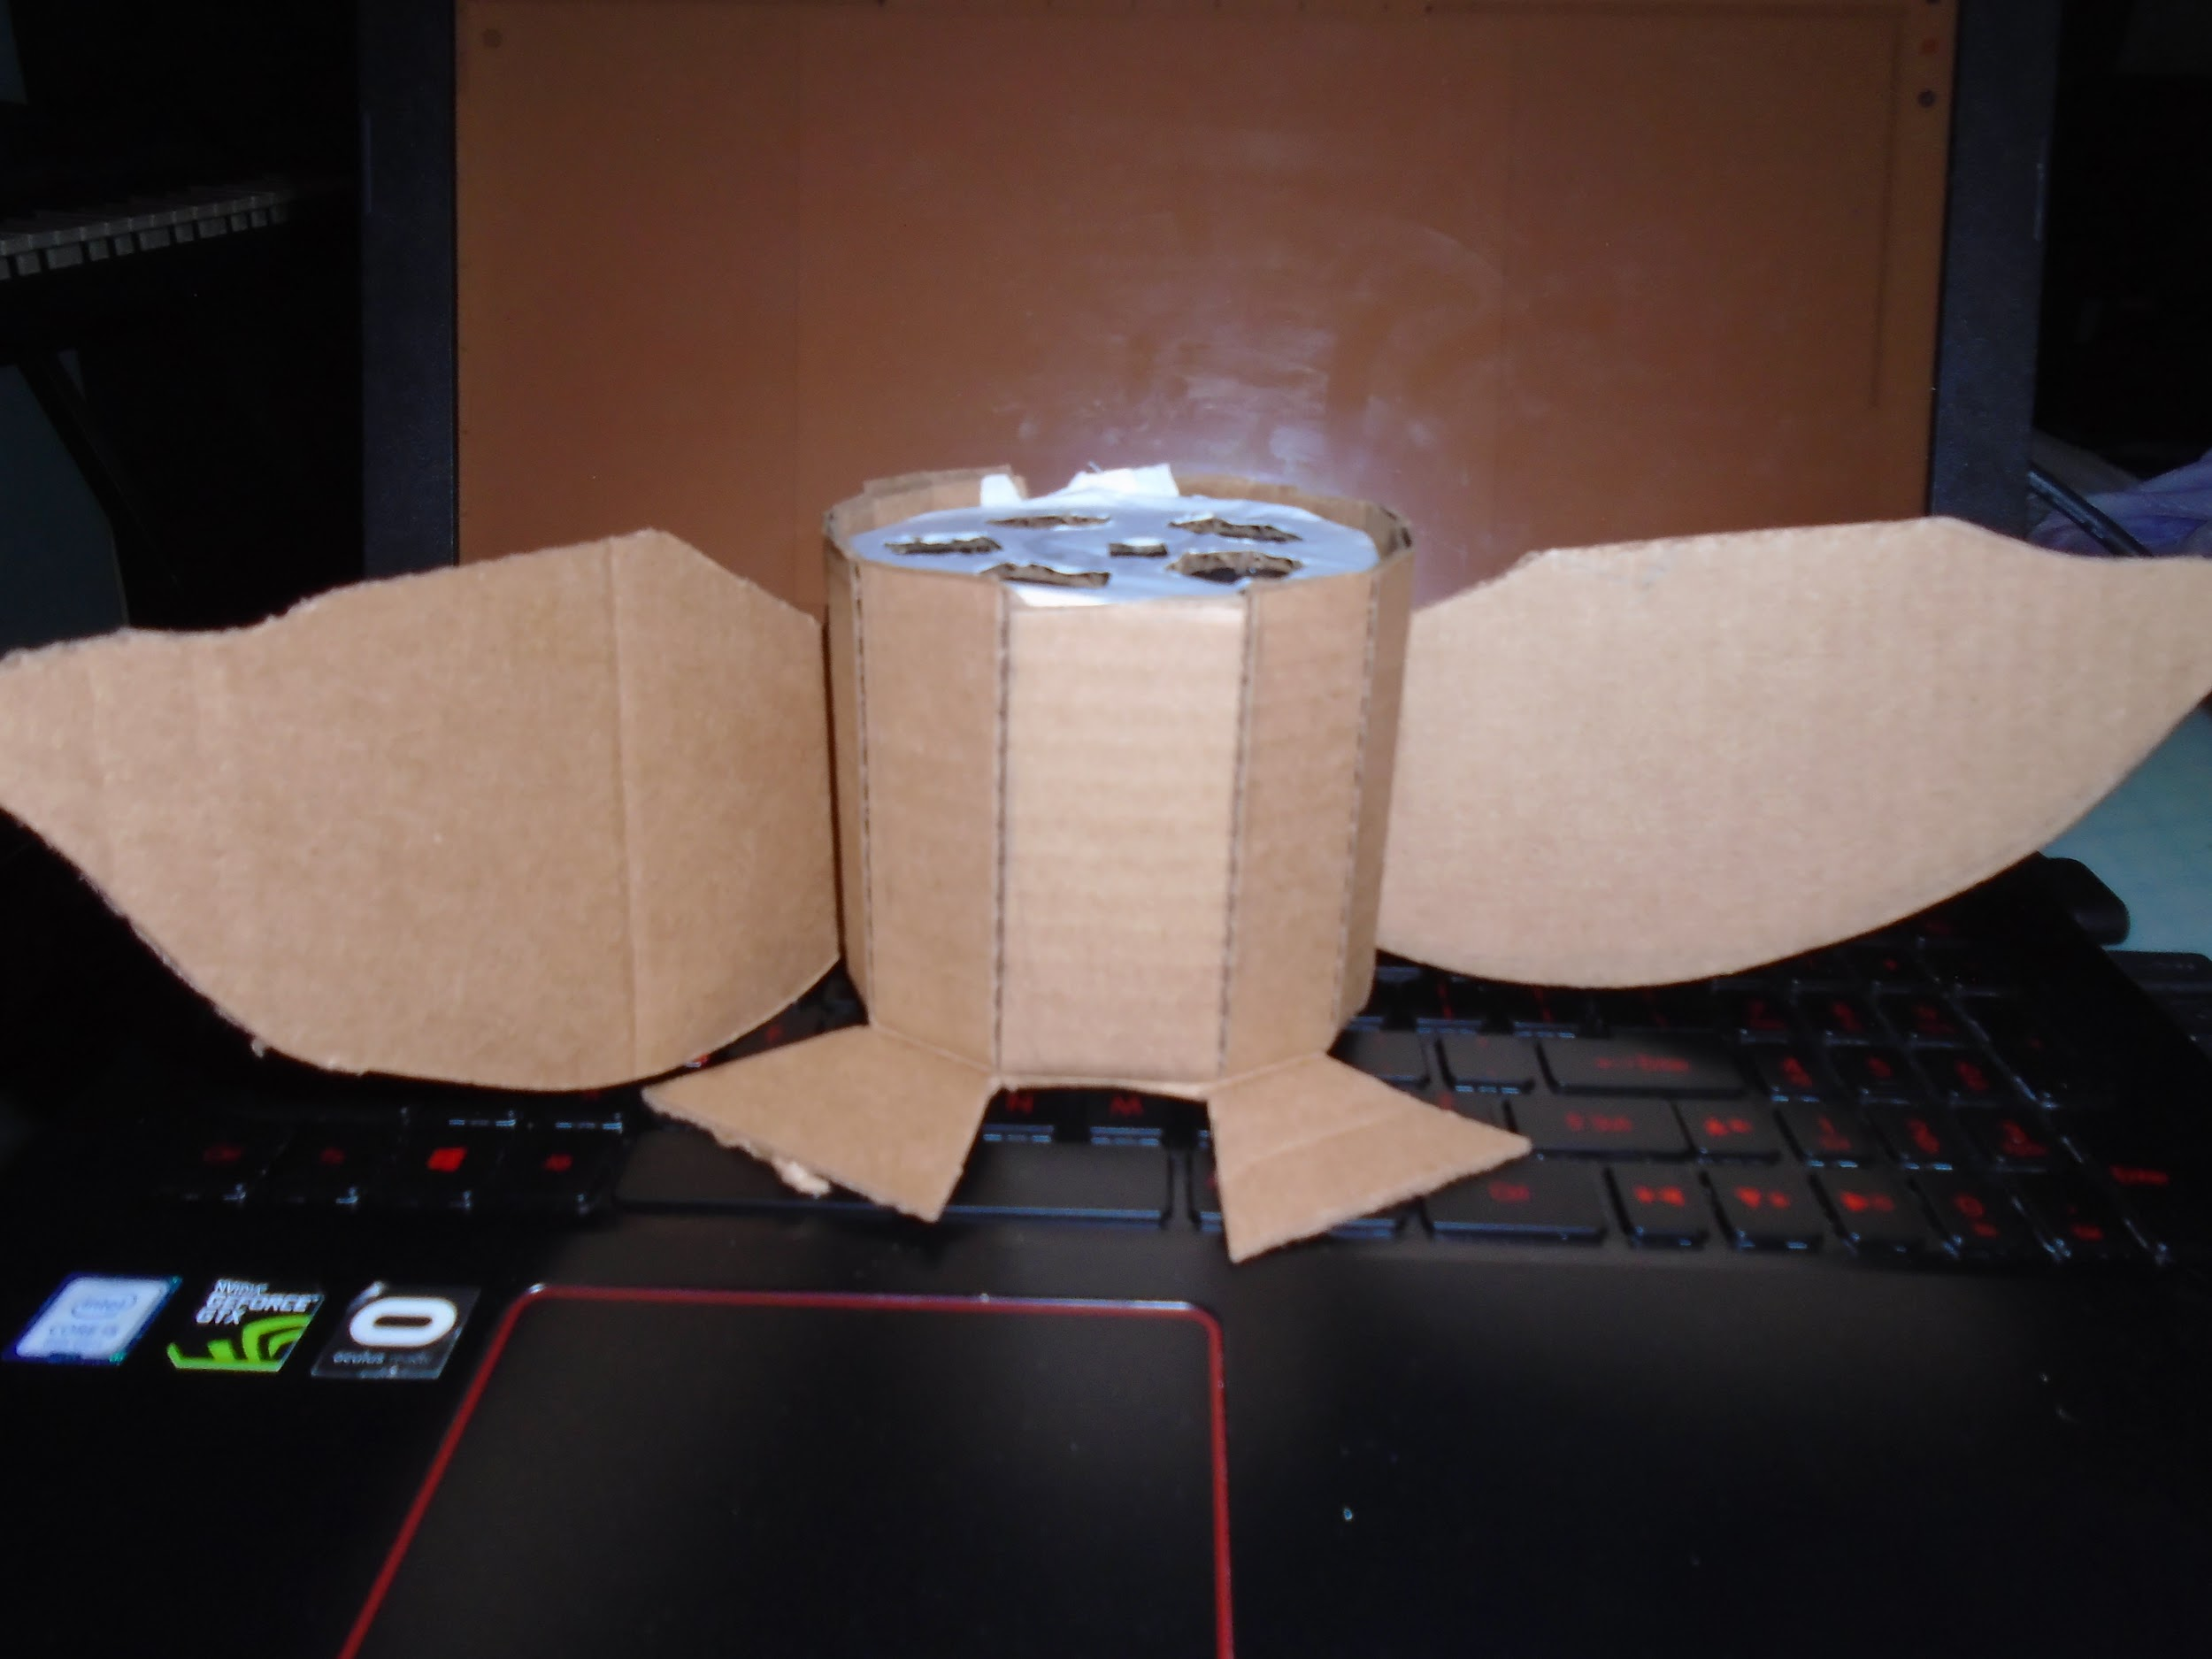

Final Product:

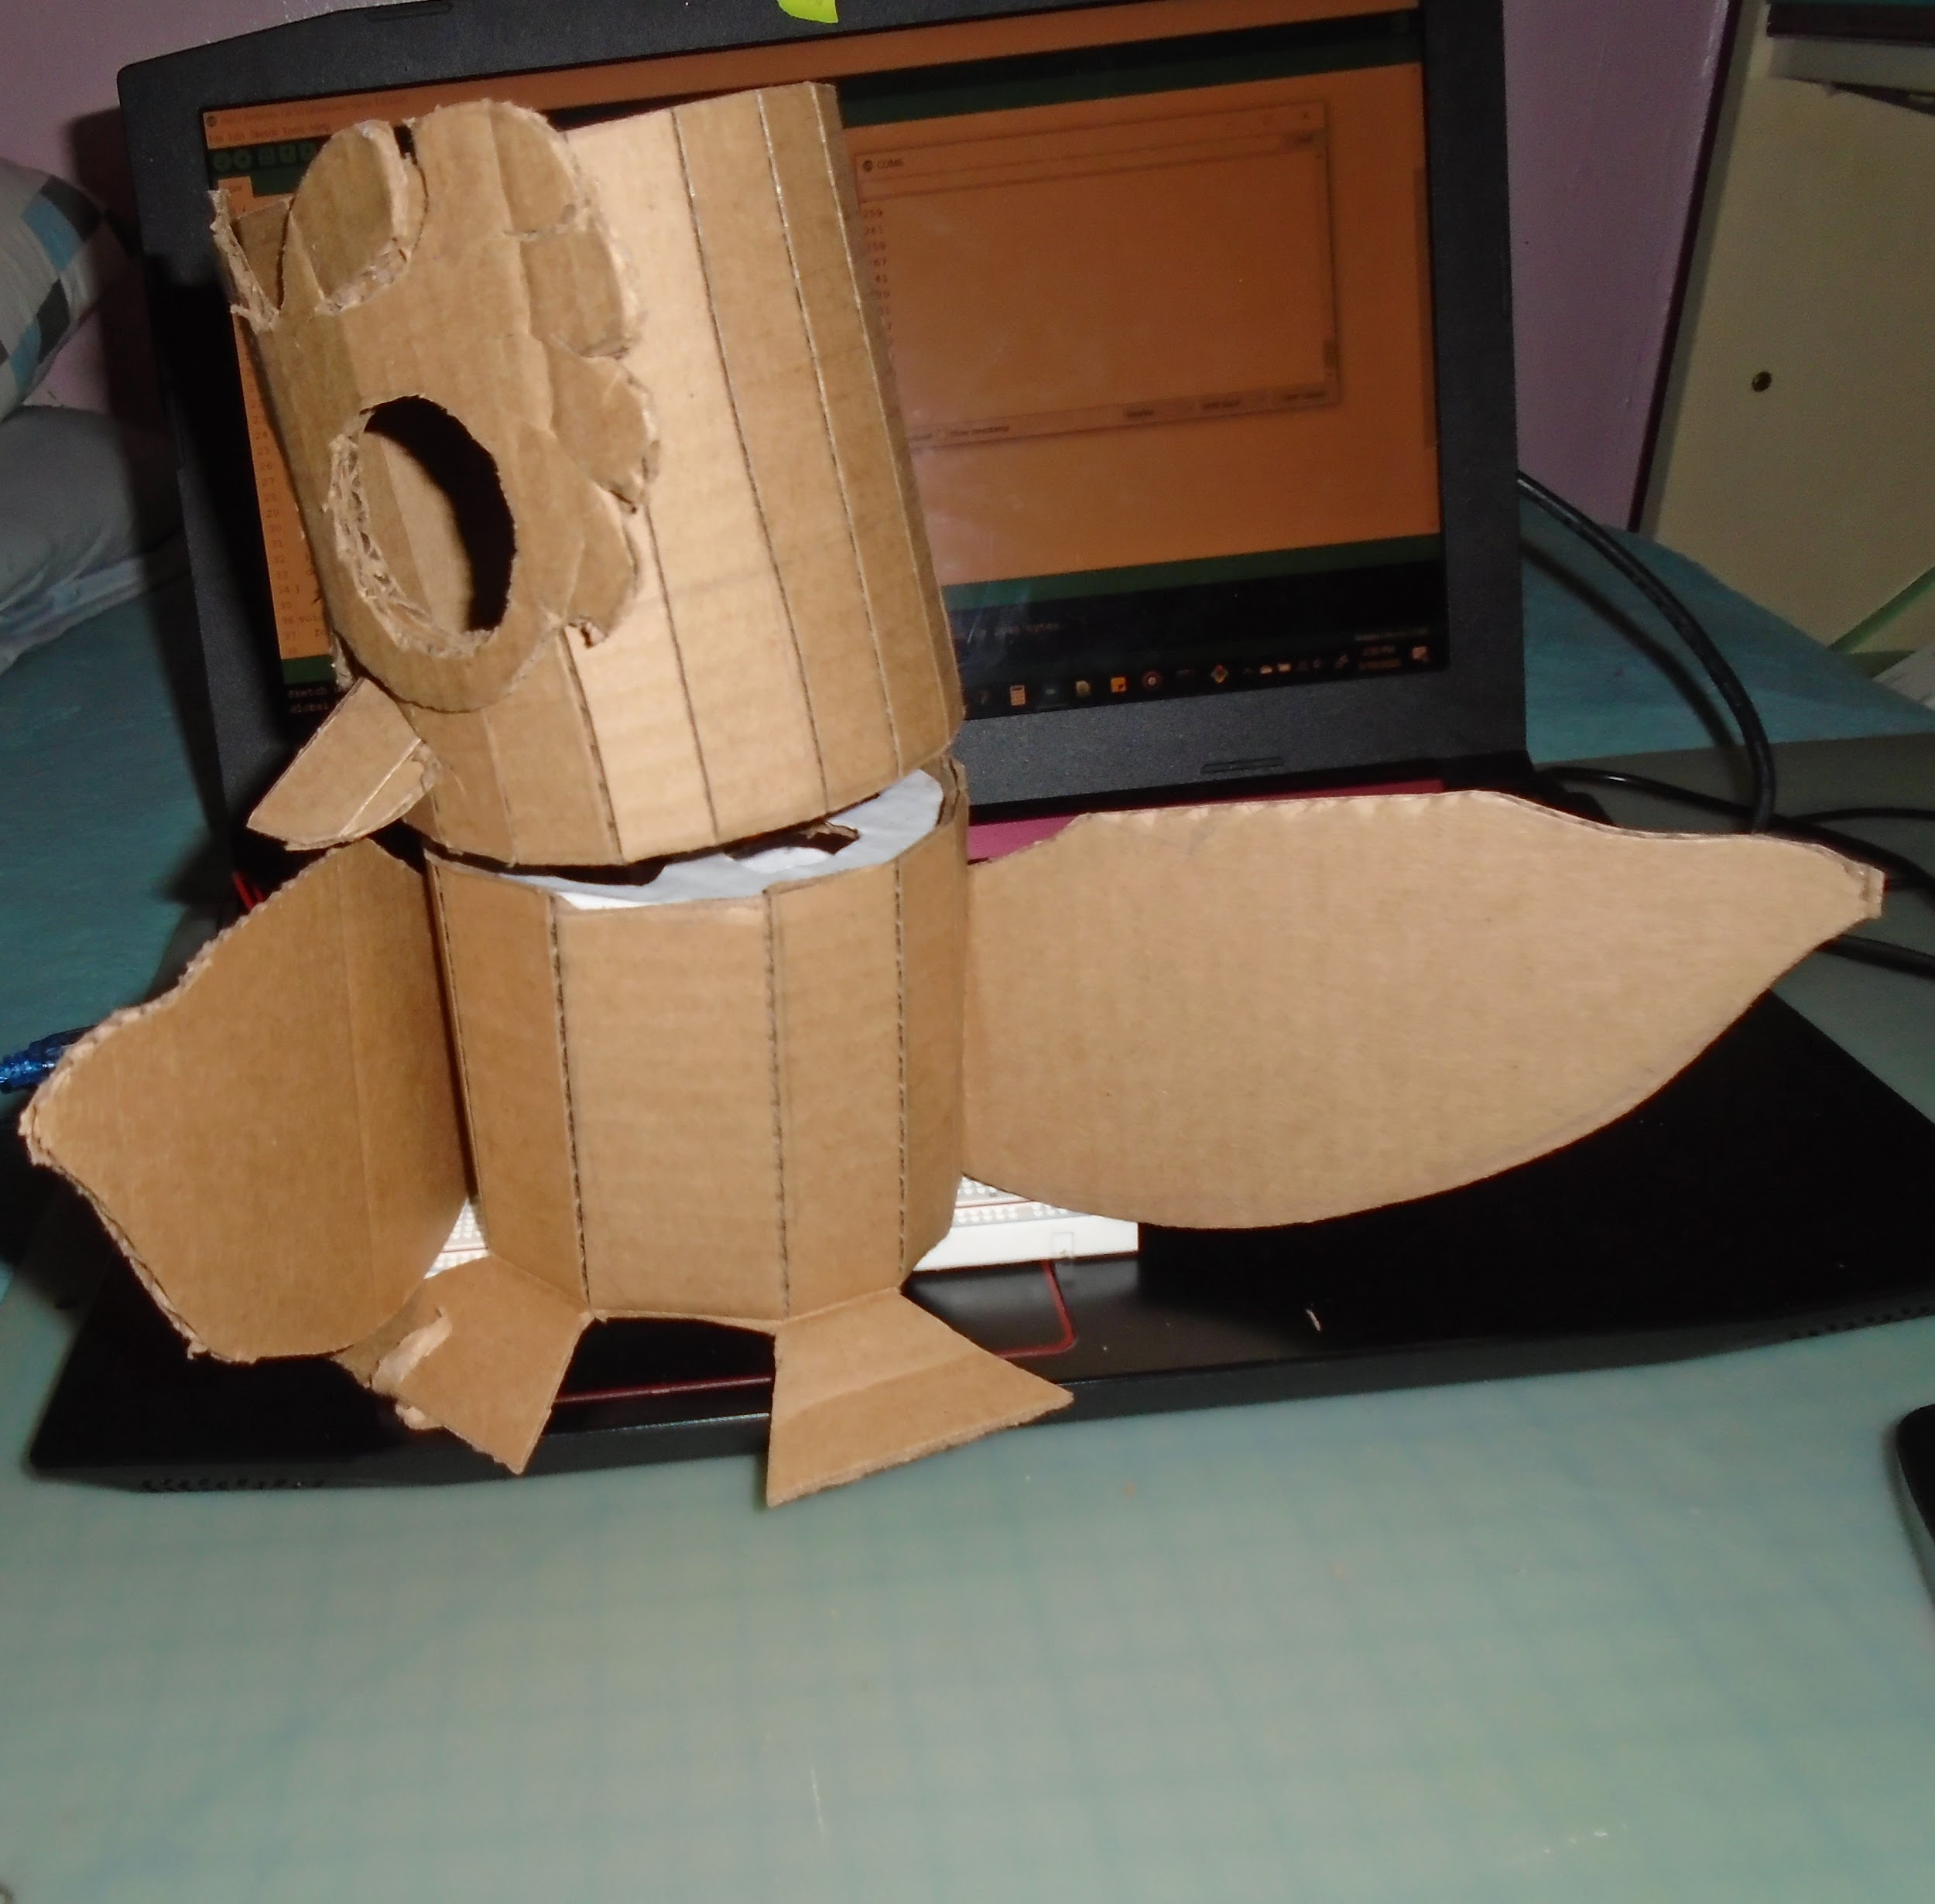

The video of the owl working is in google drive